**Asiqul Hoque  
Section 4 Lesson 3: Count, Distinct, NVL**

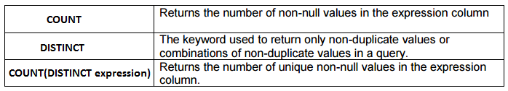

**1. select count(id)**

**from d_songs;**



**2. select count(distinct loc_type)**

**from d_venues;**



**3. select count(song_id),count(distinct cd_number)**

**from D_TRACK_LISTINGs;**



**4. select count(email)**

**from d_clients;**



**5. select count(auth_expense_amt)**

**from d_partners;**



**6. Total number of shoe colors and the number of shoes for different types of color**

**7. select round(avg(nvl(auth_expense_amt,100000)),2)**

**from d_partners;**



**8. Which statement(s) is/are True about the following SQL statement:**

**SELECT AVG(NVL(selling_bonus, 0.10))**

**FROM bonuses;**

**__F___ a. The datatypes of the values in the NVL clause can be any datatype except date**

**data.**

**__T___ b. If the selling_bonus column has a null value, 0.10 will be substituted.**

**___T__ c. There will be no null values in the selling_bonus column when the average is**

**calculated.**

**__F___ d. This statement will cause an error. There cannot be two functions in the**

**SELECT statement.**

**9. Which of the following statements is/are TRUE about the following query?**

**SELECT DISTINCT colors, sizes**

**FROM items;**

**__T___ a. Each color will appear only once in the result set.**

**__T___ b. Each size will appear only once in the result set.**

**__F___ c. Unique combinations of color and size will appear only once in the result set.**

**__F___ d. Each color and size combination will appear more than once in the result set.**